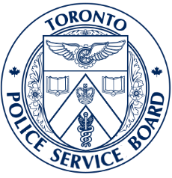

NOTICE OF SPECIAL
BOARD MEETING AGENDA
Wednesday, February 4, 2026 at 12:30PM
Virtual Meeting Link: Join the Meeting Now

Call to Order

Declarations of Interest under the Municipal Conflict of Interest Act

- Notice of Motion to waive the 24-hours notice requirement:

Section 4.4 of the Toronto Police Service Board By-Law No. 161 states:

The Board may waive any rules of procedure established by this By-Law as it considers appropriate.

- Consideration of Motion to Move In-Camera

That the Toronto Police Service Board adjourn the public portion of its special meeting to move In Camera in accordance with Section 44(2) of the Community Safety and Policing Act, 2019 to discuss a critical points matter.

Adjournment

Next Regular Board Meeting

March 4, 2026
Hybrid Board Meeting – at Police Headquarters, 40 College Street, or virtually via WebEx

Members of the Toronto Police Service Board

Shelley Carroll, Chair Chris Brillinger, Vice-Chair
Amber Morley, Member & Deputy Mayor Lisa Kostakis, Member
Lily Cheng, Member & Councillor Ann Morgan, Member
Nick Migliore, Member

