- We assume that the safety of all Toronto residents is paramount. Yet lately, it seems that Toronto Police forces are acting differently towards pro- Palestinian demonstrators when they harass people on the streets of Toronto. Pro-Palestinian or rather pro-Hamas demonstrations are taking place everywhere in the our city, interrupting traffic and interfering with the lives of Torontonians. So far Canada listed Hamas as a terrorist organization. That’s why I am wondering why there is no pursuit of a federal law and curtail these demonstration. The extreme elements are disturbing normal life of Torontonians. Police allows these extremists to do anything they want, police forces just observe how they block streets, harass people on the streets of Toronto, walking into Jewish neighbourhoods calling people “baby killers”. They walk in numbers with posters calling for “global intifada” (in their language – bloody revolution) and they are protected by Toronto police (see link for a small video https://x.com/VivianBercovici/status/1800473265367847422
We feel that Police forces are afraid of these extremists. These people bring their religious and domestic grievances from countries they arrived to a peace-loving Canadian society.
- Police presence on university campuses. Police should be present on private properties as well. The university security forces do not project the same authority as Toronto Police. All encampments and disruptions that had happened in Toronto downtown core could have been prevented, if Toronto police intervene.
- Toronto police should take on the verbal abuse that recently is happening on Toronto streets by extremists, nobody is stopping them from verbal abuse, labeling people, based on religion. There is no reprimand from the police forces in the video above when extremists abused people with labels such as “child killers” “Zionists” etc.
- Toronto Police is very selective regarding whom they arrest. See photo attached. The Jewish man was arrested. He did not block any traffic, unlike a pro Palestinian protest that blocked the Dundas square – see link https://x.com/AvivaKlompas/status/1821927615462044029
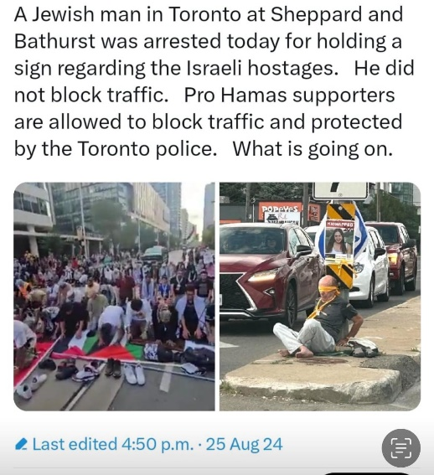
It is easy to arrest a single person- who does not disturb anybody. Much more difficult to stop praying for Hamas in the middle of the Dundas Street. And yes, we understand that when Police start removing them, the accusations of brutality, hell will open on police heads! However, the law is the law!! The massive police presence during this prayers were paid by the Toronto taxpayers.
- the “frequent protests” that have erupted in Canada due to global conflicts are not curbed by Toronto police and despite that some politicians may stand with these protesters, Toronto Police must serve the law if any obstruction to a normal life is going on. Police must stop pussyfooting around and enforce the laws already on the books;
- Police presence in schools. It is very unfortunate that police was removed from Toronto schools. It should be restored in our opinion.
- Illegal immigrants that live on Toronto streets. Immigrants must be educated that using violence to promote social change is not acceptable in Canada and will have serious consequences.
- Homeles that leave on Toronto streets. Police should enforce the normality of Toronto streets and keep Toronto downtown core clean from beggars and drug addicts.
- non-citizens who break the law should be immediately deported, no recourse.
- We, the taxpayers, have the right to expect that law enforcement does the job we pay you to do. The time has come for our police services across Canada to start enforcing our laws and prohibit pro-Palestinian protests and arrest any pro-Palestinian supporters participating in any future protests and threats against our Jewish communities. Now, over 100 Jewish synagogues and communities have been threatened with mass blast across our once great nation. I believe in the right to lawfully protest, but there are people in Canada who have now crossed the line. Our police leaders have chosen to turn a blind eye to the harmful threats like “from the river to the sea,” which means the annihilation of the Jewish race. Now, threats of mass bombings across Canada to Jewish synagogues and communities. Open your eyes and do what you are paid to do — enforce the law.

