Statement to Toronto Police Service Board

By: Clara Tucker

Thank you for the opportunity to share my views with the Board. These are the main points I’d like to raise:

GRAFITTIES: I live at the Beaches, Toronto.

The first time in my entire life that I felt threatened and insecure in my own neighborhood was during Covid. I went for a walk with my dog early in the morning, and there was graffiti on the wall of the Church across the road from my building saying, “*Jews are Pigs*”. This event stuck in my mind and my heart for months.

Today, thousands of graffiti harassing Jews are seen everywhere in the city, and attacking Jews verbally has become normalized in this city. This affects our community's mental health and safety tremendously.

PROTESTS THAT ARE NOT PEACEFUL:

I was also in the Café Landwer in Downtown Toronto when a Pro-Palestinian rally stopped in front of the Café and started yelling at people inside it. Everybody was terrified and traumatized for weeks after. Most of the protesters were wearing masks, just like Ku-Klux-Klan do, to terrify and intimidate people. Why are masked protesters allowed? Why are protesters allowed to terrorize businesses and their attendees without any punishment?

VERBAL ABUSE:

In June 2024, I attended a peaceful event in downtown Toronto for the Israeli hostages. As I was at the back of the event, I saw the Pro-Palestinian protesters exchanging wording with the Pro-Israel attendees. I saw a man from the Pro-Palestinian side harassing little Jewish kids, telling them that their parents were pigs and murderers. Why is such blatant harassment of Jews permitted?

As a Jew, I’m afraid to go to downtown Toronto. I’m afraid to walk in my own neighborhood, showing my Jewish identity as little as wearing a Star of David. I’m afraid to go to work. I feel we are in a new pre-Holocaust period, just like 1930’s in Germany.

Thank you for the opportunity to speak up.

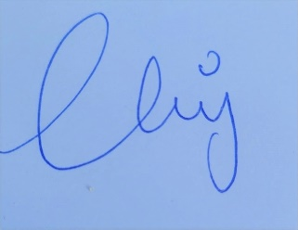

Clara Tucker

412- 1765 Queen Street East, Toronto